Process :
- Perform baseline correction and linear detrending to each of the 25 waveforms ( 5 from each finger).
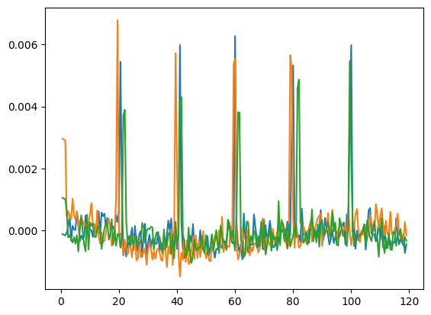
- Extracted 5 spikes from the 25 waveforms and applied cublic spline. A sample is show below.
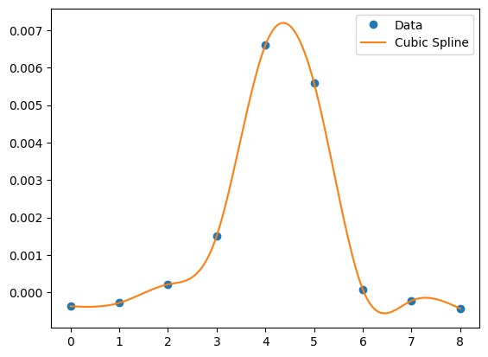
- Extracted features such as 'P2P', 'RMS', 'Max', 'RiseTime', 'FallTime', 'StdDev', 'Skew', 'Krtosis', 'MaxSlope', 'FFT_Mean' and ‘Fwhm’.
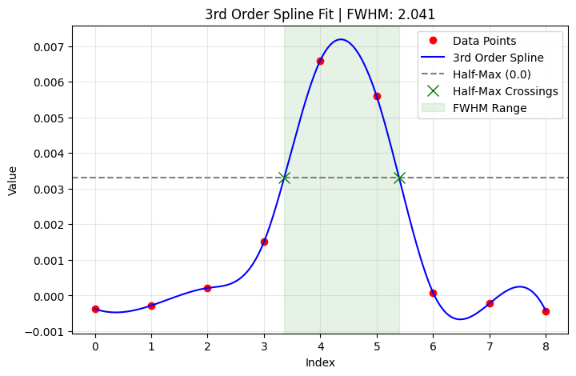

Data Analysis Key Findings
The models and their corresponding accuracies are:
  - KNN (3-class): 77.33%
  - SVM (3-class): 76.00%
  - XGBoost (3-class): 72.00%
  - PCA + LDA (3-class): 65.33%
  - LDA (3-class): 60.00%
  - Gaussian Naive Bayes (3-class): 54.67%
  - Random Forest (5-class): 52.80%
KNN demonstrated the highest accuracy at 77.33% for 3-class classification (between index, ring and middle finger), followed closely by SVM at 76.00% for the same classification type.
The lowest performance was observed with Random Forest (5-class) at 52.80% and Gaussian Naive Bayes (3-class) at 54.67%.

Conclusion :
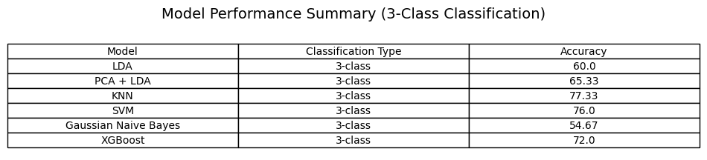

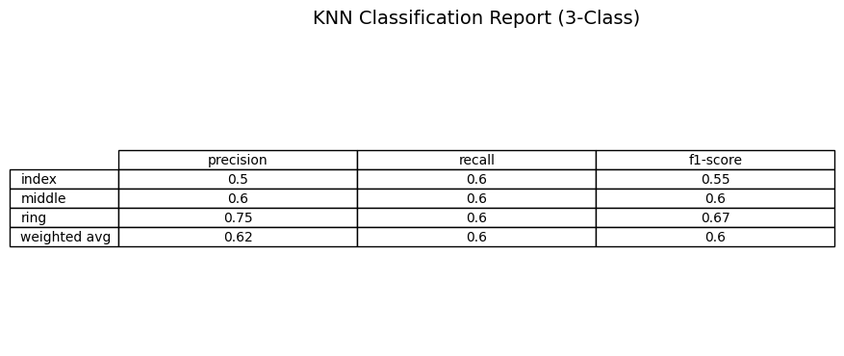
AUC Score for Best KNN: 0.79

AUC Score for Best SVM: 0.66

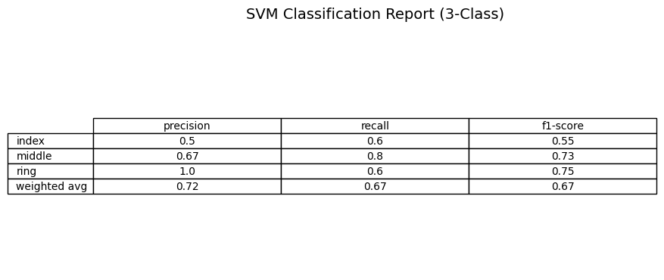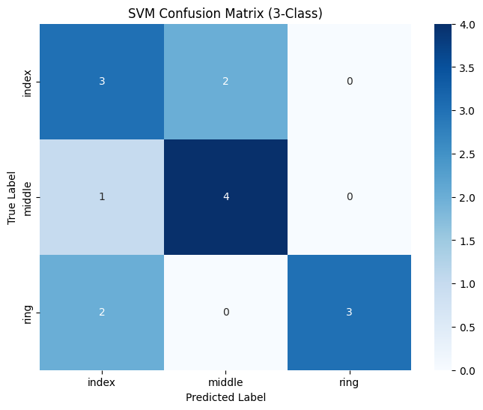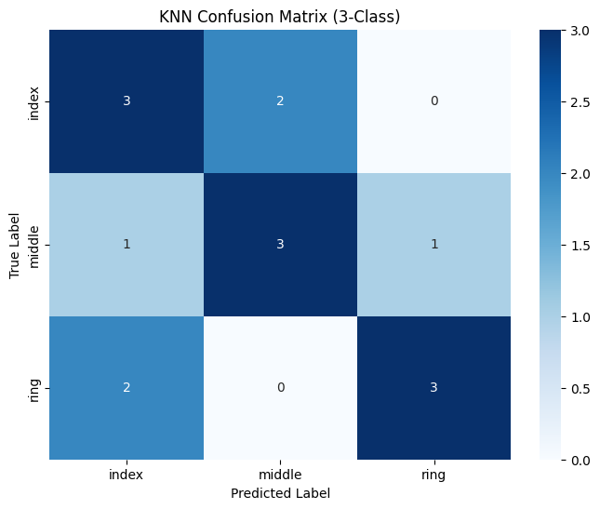

Process:
- Data Preparation and Selection: We started by carefully selecting the relevant data for the 3-class classification problem. This involved taking only the engineered features such as P2P , FWHM, etc, and the corresponding finger labels (y_three) for 'index', 'middle', and 'ring' fingers. For the algorithms to work, these labels were converted from text names into numerical codes (like 0, 1, 2) using a LabelEncoder.
- Data Preprocessing (Cleaning and Scaling): Before any model saw the data, two important steps were performed:
  - Imputation: Any missing values in the features were filled in, typically by using the average value of that feature, to ensure the models wouldn't break down due to gaps in the data.
  - Scaling: All features were adjusted so they had a similar range of values. This is crucial for models like KNN and SVM, which rely on distances between data points. Without scaling, a feature with naturally larger numbers (e.g., 'RiseTime') could unfairly influence the model more than a feature with smaller numbers (e.g., 'P2P').
- Data Splitting (Training and Testing): The prepared and preprocessed data was then divided into two sets:
  - Training Set: About 80% of the data was used to teach the models the patterns and relationships. This is what the model 'learns' from.
  - Testing Set: The remaining 20% was held back and kept completely separate. This data is unseen by the model during training, and it's used only at the very end to evaluate how well the trained model can predict new, real-world examples.
  - Stratified Split: This split was done in a 'stratified' way, meaning we made sure that the training and testing sets had roughly the same proportions of 'index', 'middle', and 'ring' finger samples as the original dataset. This prevents one set from being biased towards certain finger types.
- Model Training and Hyperparameter Tuning with 5-Fold Stratified Cross-Validation:
  - Hyperparameters: Think of these as the 'control knobs' or 'settings' that determine how a model learns and makes predictions. For KNN, this includes things like how many 'neighbors' it looks at (n_neighbors). For SVM, it involves parameters like C (how much to penalize errors) and gamma (how much influence a single training example has).
  - GridSearchCV: We used a technique called GridSearchCV to systematically try out many different combinations of these control knobs. For each combination, it built a version of the model.
  - 5-Fold Stratified Cross-Validation: To find the best combination of settings, GridSearchCV performed a 5-fold stratified cross-validation on the training set. This means:
    - The training set was divided into 5 equal 'folds' or segments.
    - The model (with a specific set of hyperparameters) was trained on 4 of these folds and then tested on the 1 remaining fold.
    - This process was repeated 5 times, each time using a different fold as the test set.
    - The performance (accuracy) from these 5 rounds was then averaged. This average is a very reliable indicator of how well that particular set of hyperparameters performs, as it accounts for variability across different data subsets.
- Selecting the Best Model: After testing all hyperparameter combinations through cross-validation, GridSearchCV automatically identified the set of 'control knob' settings that achieved the highest average accuracy.
- Final Evaluation on Unseen Data: Finally, this 'best' model (with its optimal settings) was used to make predictions on the completely separate 20% testing set. This is where we generated the final performance metrics like Accuracy, Precision, Recall, F1-score, and AUC. These metrics tell us how well our chosen model is expected to perform on truly new data.

